# COMP1150/MMCC1011 Game Design Task Report

**Name**: Zhi Jie Chair

**Student ID**: 45707650  
**GitHub username:** jackchair

Unity features used in this assignment:

|  |  |  |
| --- | --- | --- |
| **Effect / Feature** | **Marks** | **Check if used** |
| An **outdoor** section built using the Terrain editor | 25% | **✓** |
| An **indoor** section built using Unity primitives (cubes, spheres, etc) and/or ProBuilder | 25% | **✓** |
| A **First Person controller** with which the player can navigate the scene. | - | **✓** |
| Appropriate [textures](https://docs.unity3d.com/Manual/Shaders.html) on the indoor section | 5% | **✓** |
| Textures with [normal maps](https://docs.unity3d.com/Manual/StandardShaderMaterialParameterNormalMap.html) | 5% | **✓** |
| A simple single-state [animation clips](https://docs.unity3d.com/Manual/animeditor-UsingAnimationEditor.html) | 5% | **✓** |
| A [multi-state animation](https://docs.unity3d.com/Manual/AnimationStateMachines.html) that responds to trigger or mouse events | 5% | **✓** |
| Direct [light sources](https://docs.unity3d.com/Manual/LightSources.html) beyond the default Directional Light | 5% | **✓** |
| [Baked indirect lighting](https://docs.unity3d.com/Manual/LightMode-Baked.html) in the Indoor section | 5% | **✓** |
| Use of [light-probes](https://docs.unity3d.com/Manual/LightProbes.html) for dynamic indirect lighting | 5% |  |
| Use of [reflection-probes](https://docs.unity3d.com/Manual/ReflectionProbes.html) and reflective surfaces | 5% |  |
| Appropriately chosen [post-processing effects](https://docs.unity3d.com/Manual/PostProcessingOverview.html) | 5% | **✓** |
| Use of [multiple cameras](https://docs.unity3d.com/Manual/CamerasOverview.html) (e.g. overlaid cameras or rendering to a texture) | 10% | **✓** |
| [Particle systems](https://docs.unity3d.com/Manual/ParticleSystems.html) | 10% | **✓** |
| Objects controlled by [physics](https://docs.unity3d.com/Manual/PhysicsSection.html) | 5% | **✓** |
| Using [joints](https://docs.unity3d.com/Manual/Joints.html) | 5% | **✓** |
| Appropriate 3D spatialised [audio sources](https://docs.unity3d.com/Manual/AudioOverview.html) | 5% | **✓** |
| Using [reverb zones](https://docs.unity3d.com/Manual/class-AudioReverbZone.html)**,**[effects](https://docs.unity3d.com/Manual/class-AudioEffectMixer.html) and [filters](https://docs.unity3d.com/Manual/class-AudioEffect.html) | 5% | **✓** |
| **TOTAL:** | **125%** |  |

**Note:** Totals greater than 100% will be rounded down.

On the following pages you should indicate where each of the above features appear in your game, using screenshots to direct the marker. You will not get marks for a feature that is not documented in your submitted report. Additionally, features will not receive marks if they cannot be easily located within your scene and hierarchy.

Ensure your completed report is both included in your assignment repository (on GitHub) and submitted via the Game Design Task submission link on iLearn. Submission of this report via iLearn notifies the markers that your Game Design Task GitHub repository is ready to be marked.

## 1. Terrain

**Features used**:

* An **outdoor** section built using the Terrain editor
* Material with natural shader

**Where in Hierarchy**

* /Terrain

**Description**:

The terrain consists a house surrounded by mountains on one side and trees on the other side. There is a water pole behind the house which is filled with water. Also, a mine has located near the water pole, but the path to go inside was blocked. House and mine using normal maps as texture, while terrain use multiple terrain layers to paint texture. Mountains near the mine don’t have tree while the other have. Ground level is covered with trees and two different grass detailed using billboarded.

**Screenshot**:

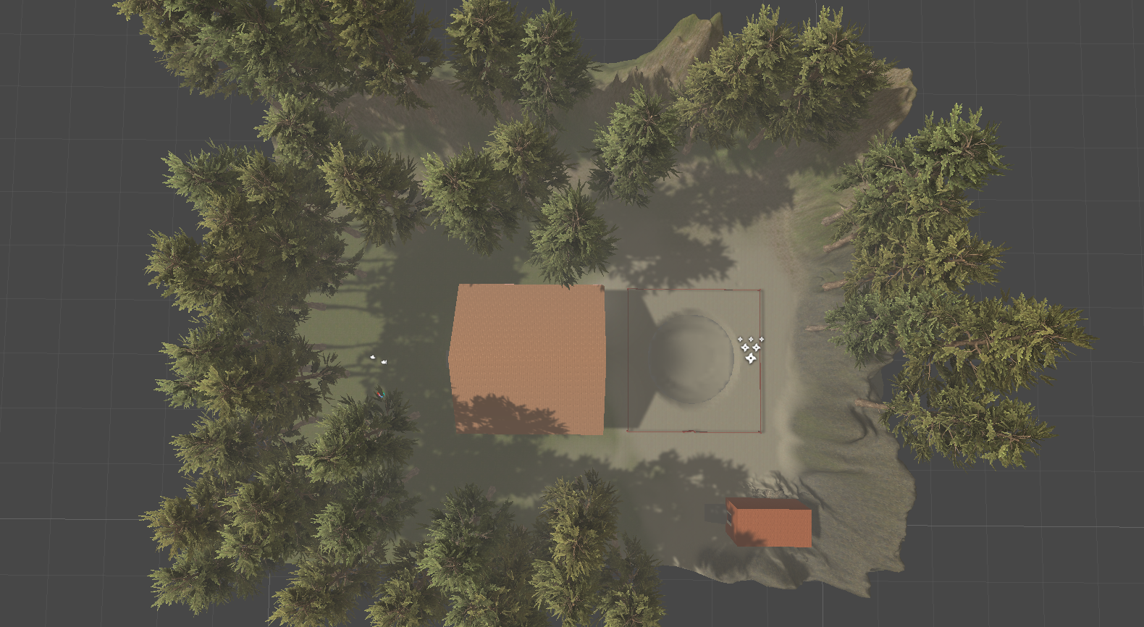

Figure 1: Terrain

## 2. Environment

**Features used**:

* A **post-processing** effect on player
* **Multiple cameras** used
* **Audio source** used and change feature on reverb zones, effects and filters

**Where in Hierarchy**

* /PostProcessor
* /FPSController
* /CameraTop
* /CameraBottom
* /CameraPointingAtHouse
* /CameraUnderWater
* /CameraInsideMine
* /CameraPointingAtMap
* /Terrain

**Description**:

A post-processing effect was built on player. It is local post-processing to make player change different colors when near fire or go into the mine.

Many cameras used in different ways to see on different aspect. Both cameras set depth to -1, while FPS Controller set to 0. It is use to control player and see on player camera site only.

Audio source was put in terrain as a component. This audio is raining sound, and the features have been changed. Making the sound more appropriate to the environment.

**Screenshot**:

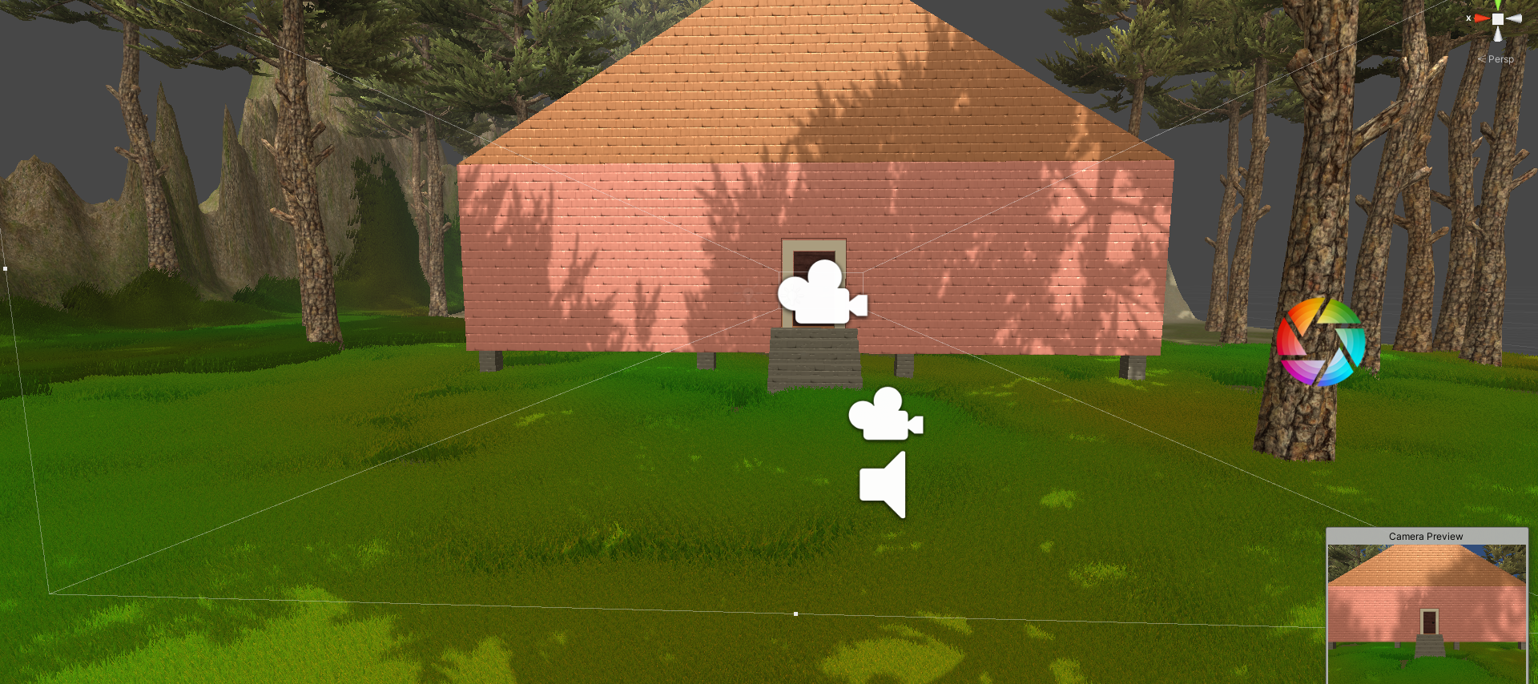

Figure 2: Post-processing and FPS Controller Camera, also an audio clip inside the terrain

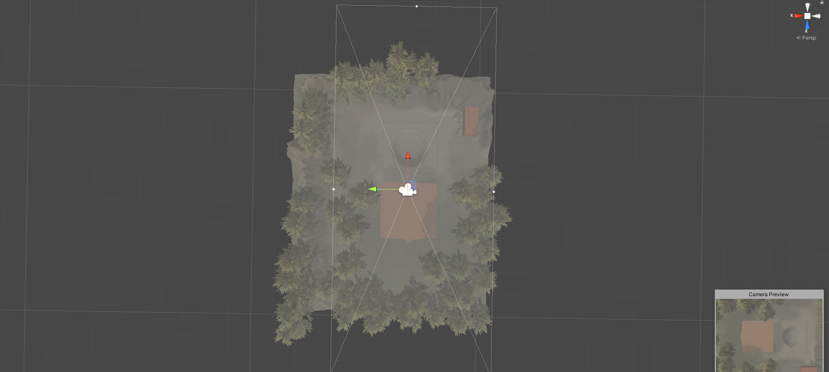

Figure 3: CameraTop

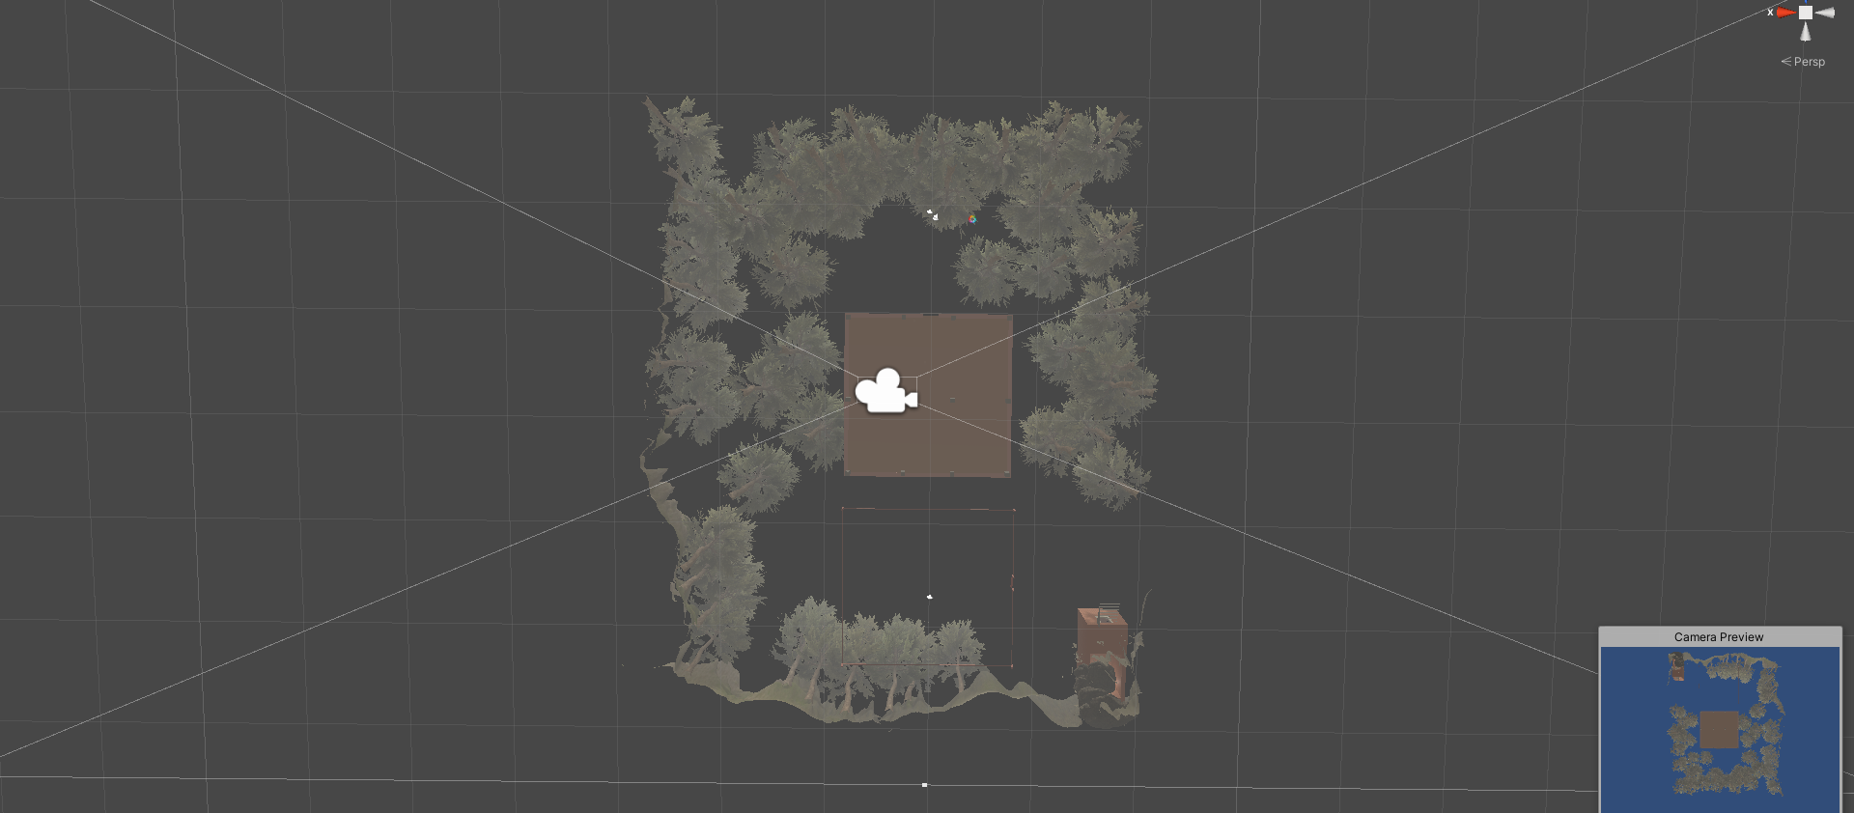

Figure 4: CameraBottom

## 3. Indoor Section

**Features used**:

* Textures with **normal maps**
* Baked indirect lightning lamp
* Rotate trigger animation of vase
* Open and close door animation when clicked on mouse
* Torch with fire particle system

**Where in Hierarchy**

* /House and /Mine
* /House/BedRoom/Light
* /House/StuffsTable/Light
* /House/CabinetOutsideBedRoom/Light
* /House/Box/Light
* /House/StuffsTable/Light
* /House/MainDoor
* /House/DoorOfBedRoom
* /Mine/Door
* /Mine/Torch1/FireParticle
* /Mine/Torch2/FireParticle

**Description**:

A house which contains ceiling, floor, house foot, stairs, bedroom, tables, and a box using normal map texture. While the others, map and doors, is an imported picture and animation. A mine which contains walls and stairs using normal map.

Inside house have Bedroom, table that place stuffs, cabinet outside bedroom, and a mystery box. Each of them has a baked indirect light contains in a lamp and place near them. Lamps will light up the entire house in every corners.

A player trigger animation was set on a vase place on the stuffs table. When player walk near the table, it will start the animator. This animation is set with one side, which will rotate but never return to default.

A player click animation was set on every door in house and mine, when player click the door will open, click again will close. This animation is set with two side.

Inside mine have two torches. Each of the torch will have a fire particles system set in it. The fire will light up the mine.

**Screenshot**:

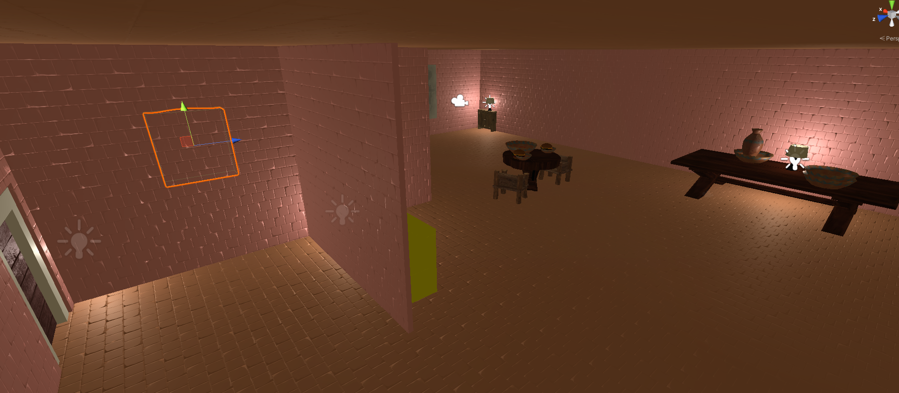

Figure 5: Indoor section

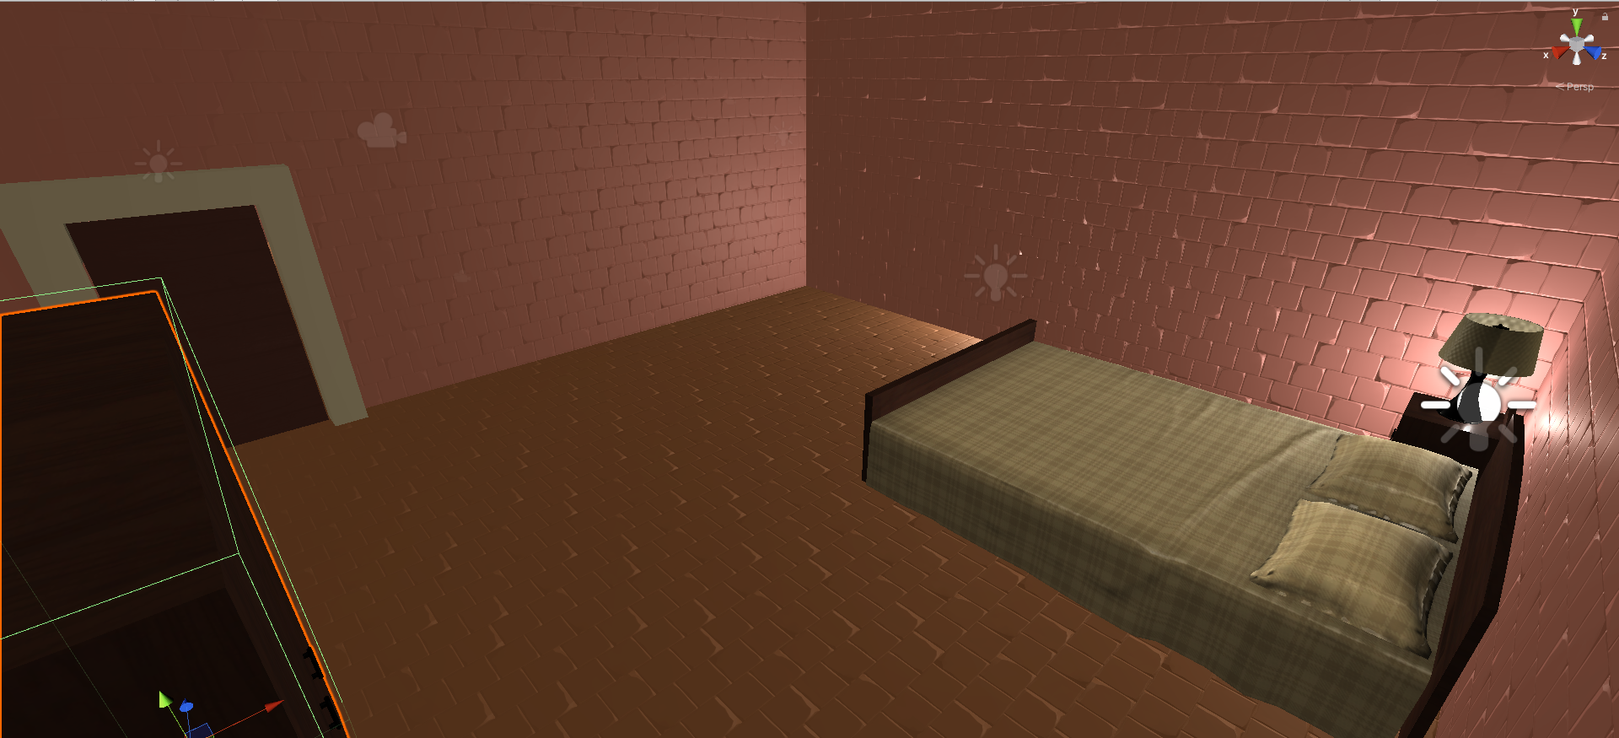

Figure 6: Bedroom

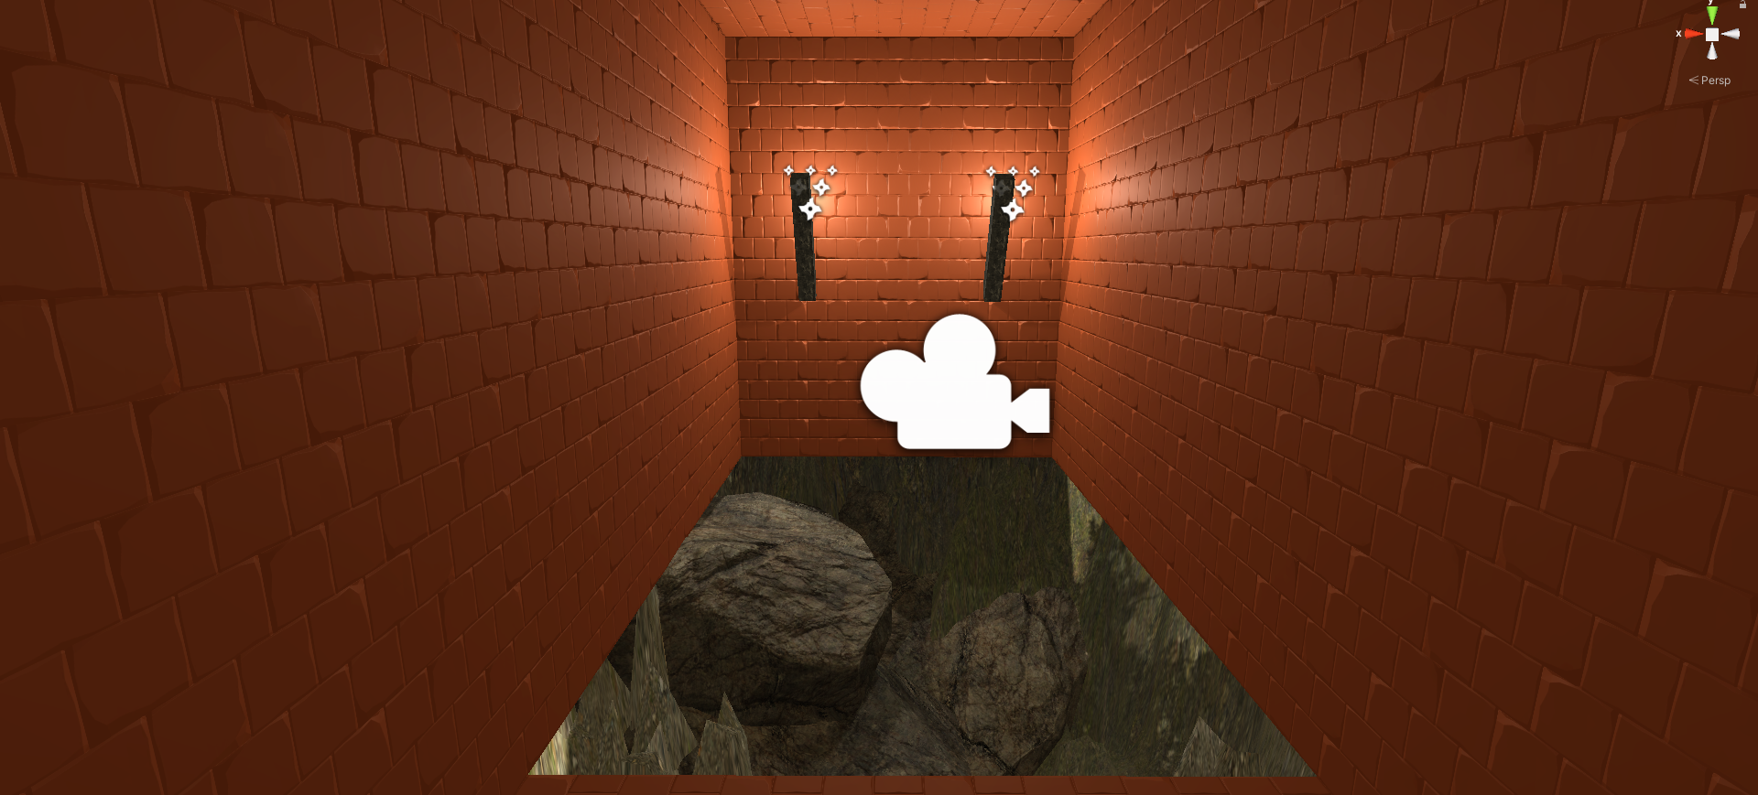

Figure 7: Mine

## 4. Animation

**Features used**:

* **Many multi-state animation** that responds to click on mouse
* A **single-state animation** the responds to trigger

**Where in Hierarchy**

* /House/MainDoor
* /House/DoorOfBedRoom
* /Mine/Door
* /House/StuffsTable/vase_broken

**Description**:

Both multi-state animation is trigger while player click the door. It have two animation which is open and close. Open when the door is close and player click on the door, close when the door is open and player click again.

A single-state animation is occurred when player go near the vase. It is set with a trigger. This trigger is a box collider.

**Screenshot**:

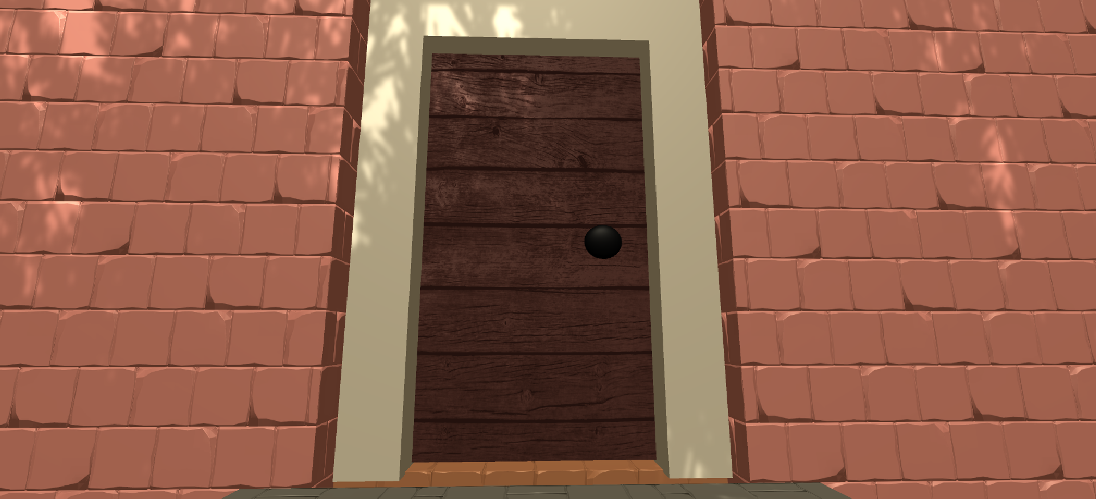

Figure 8: Door in closing state

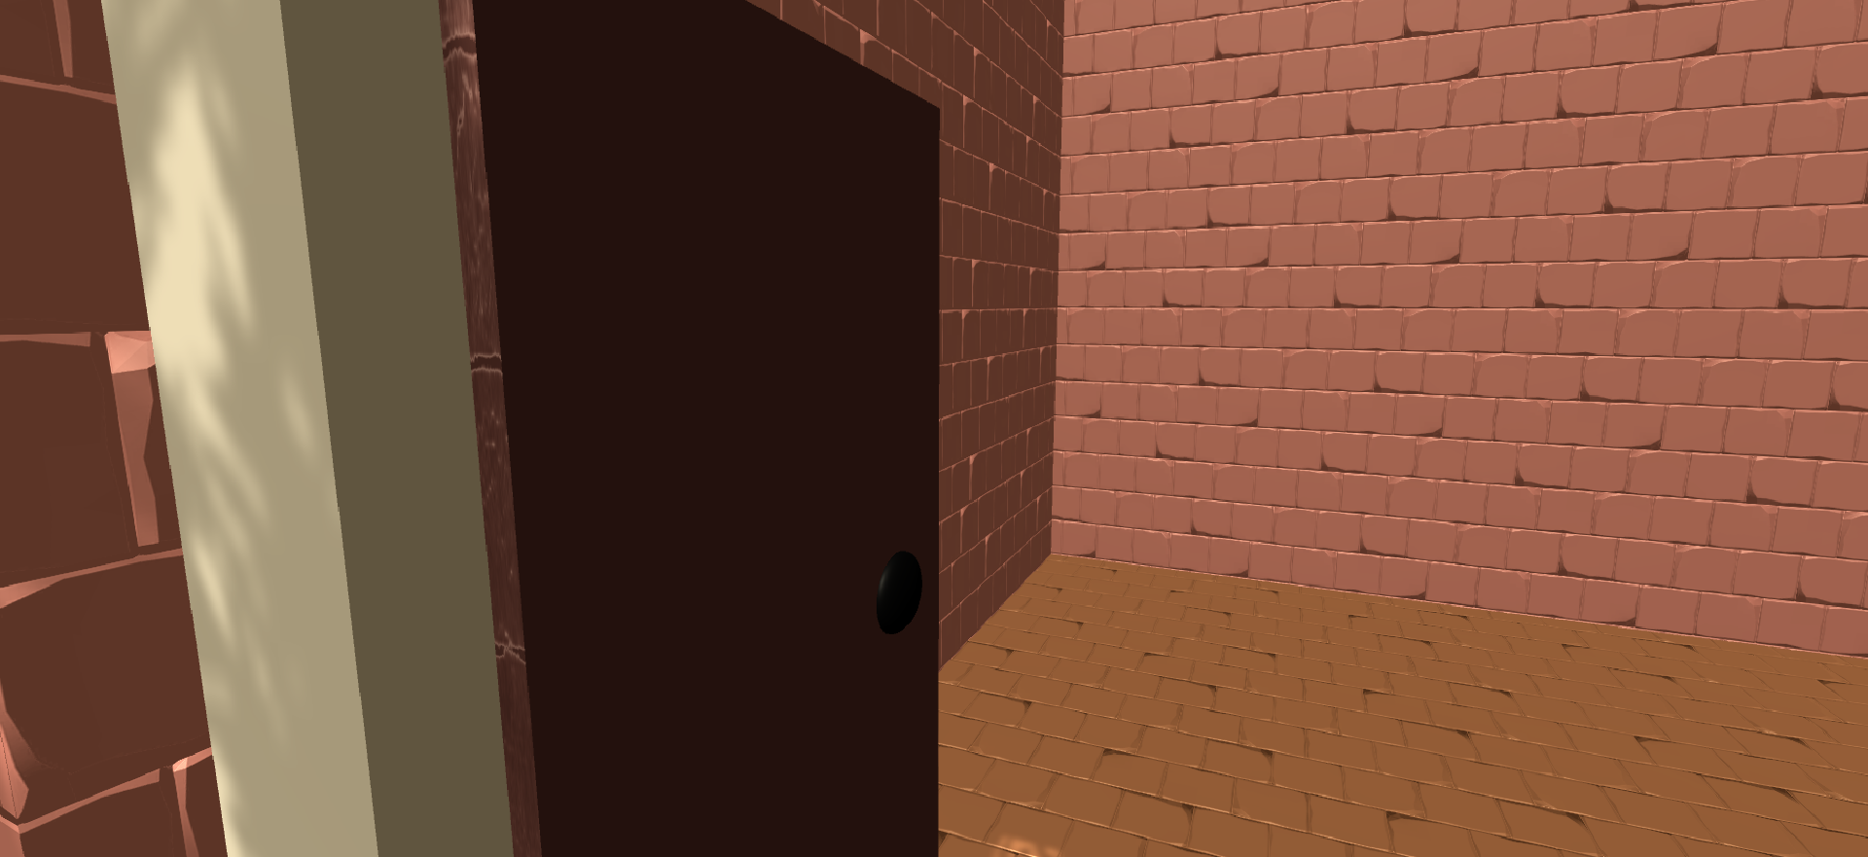

Figure 9: Door in open state

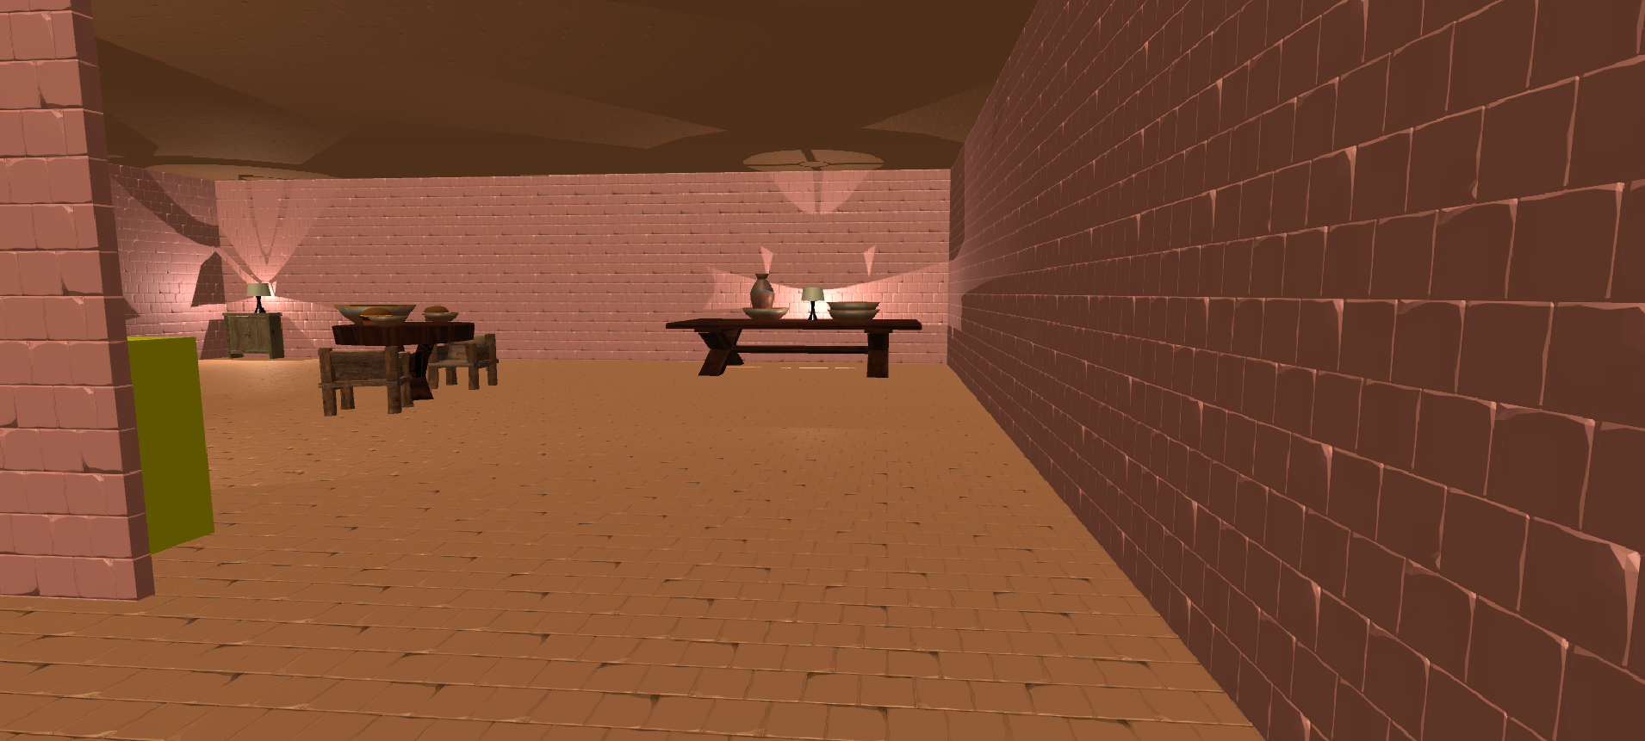

Figure 10: Vase in normal state

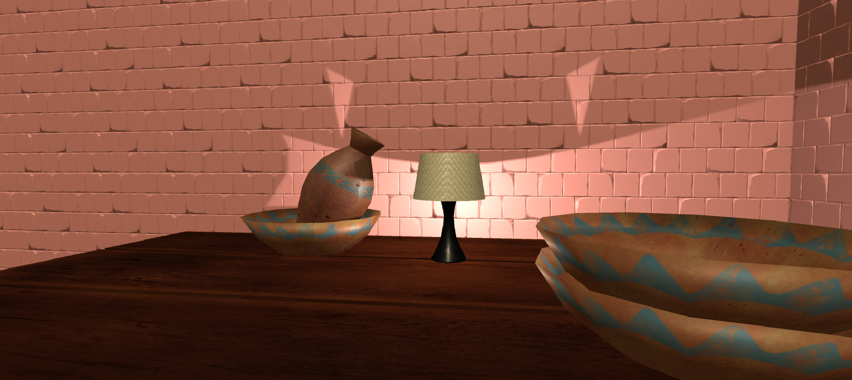

Figure 11: Vase have been rotated

## 5. Light

**Features used**:

* A **Direct light sources** which as default light
* **Baked indirect lightning** use in indoor

**Where in Hierarchy**

* /Directional Light
* /House/StuffsTable/Light
* /House/BedRoom/Light
* /House/Box/Light
* /House/CabinetOutsideBedRoom/Light

**Description**:

A direct light sources was built beyond the default light, making it directional while change some feature, such as strength of light, resolution, etc.

Baked indirect lightning place in a lamp was used to light up the house in every corners. The shadow type is change to soft shadow to have shadows of objects.

**Screenshot**:

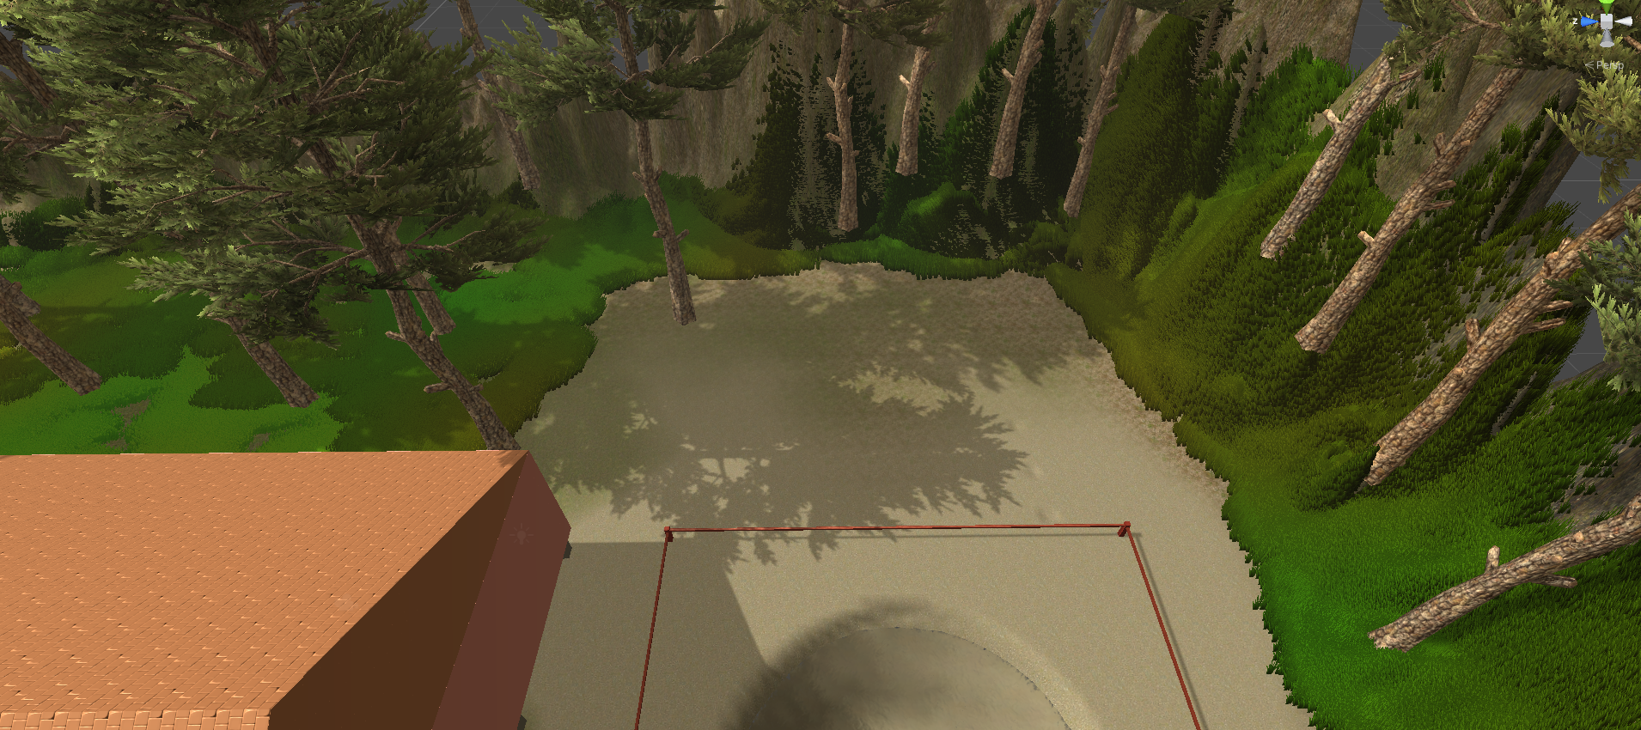

Figure 12: Directional light

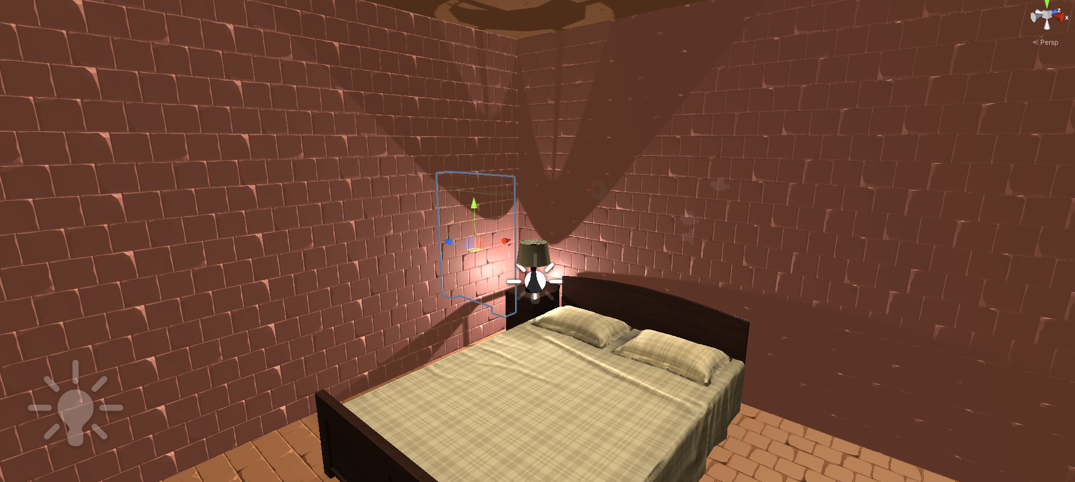

Figure 13: Baked indirect light

## 6. Particle Systems

**Features used**:

* **Fire particle systems** set on torches
* **Raining particle system** used to raining

**Where in Hierarchy**

* /Mine/Torch1/FireParticle
* /Mine/Torch2/FireParticle
* /RainingParticle

**Description**:

Fire particle systems set on torches to light up mine, and also, it will change the color when burning.

Raining particle systems used to drop rain on the terrain. Rain will spread when falling on ground. When raining and when fall on ground, both colors are the same. Also, it will no go through building.

**Screenshot**:

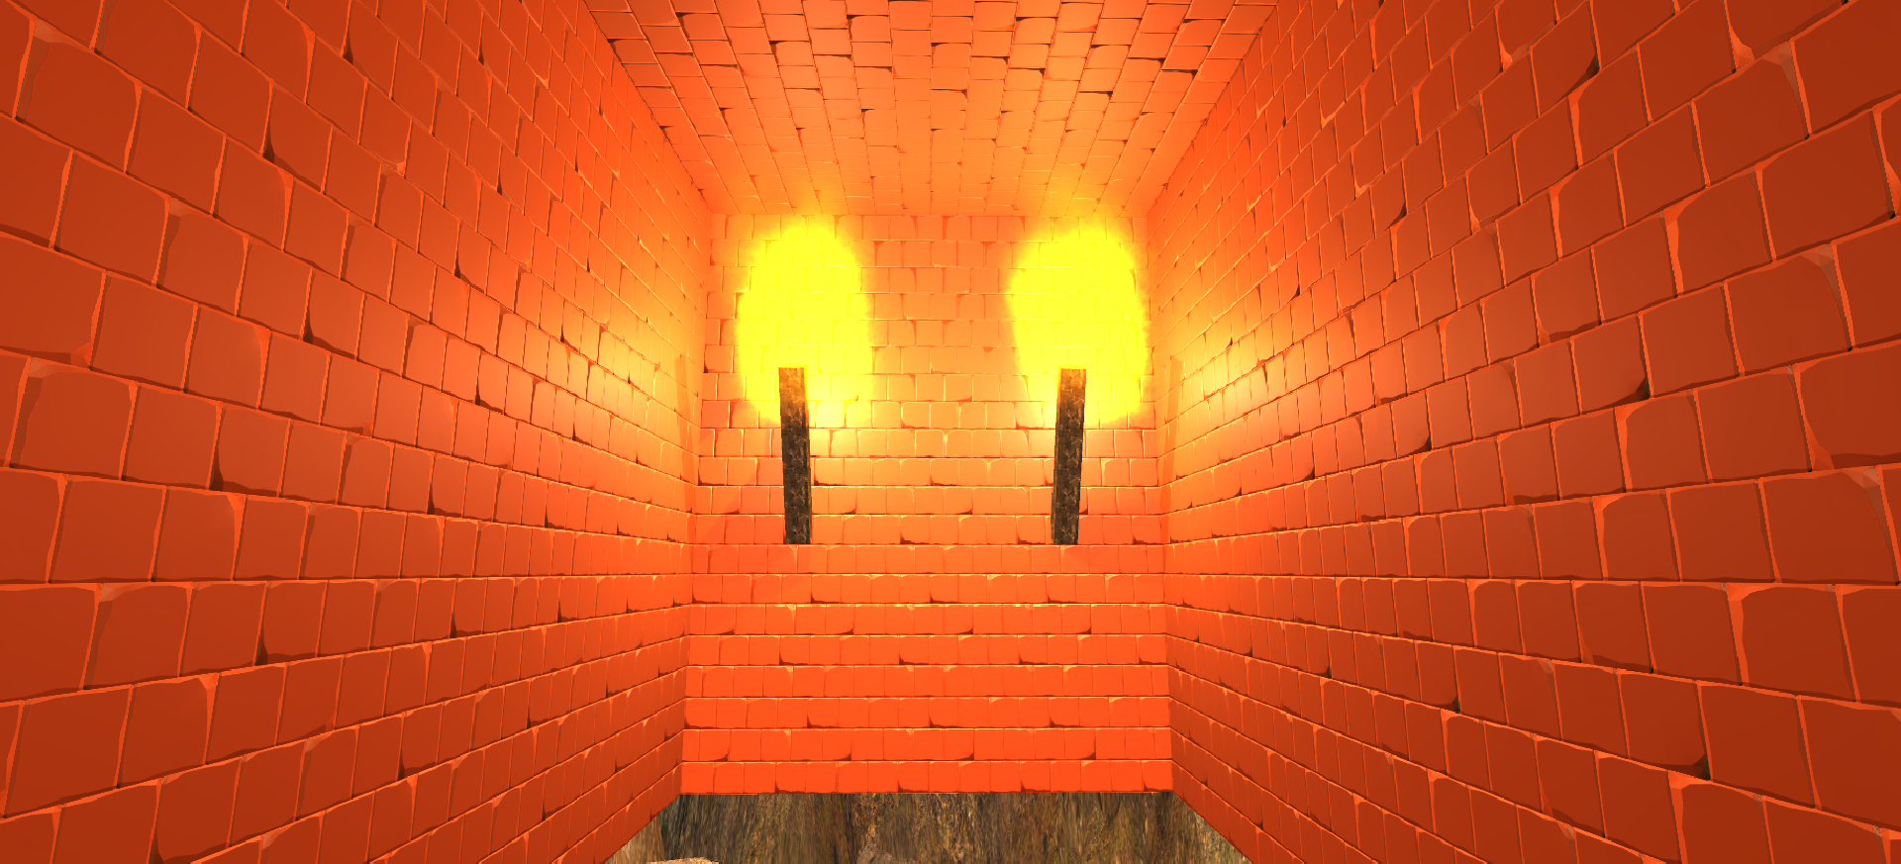

Figure 14: Fire Particle System

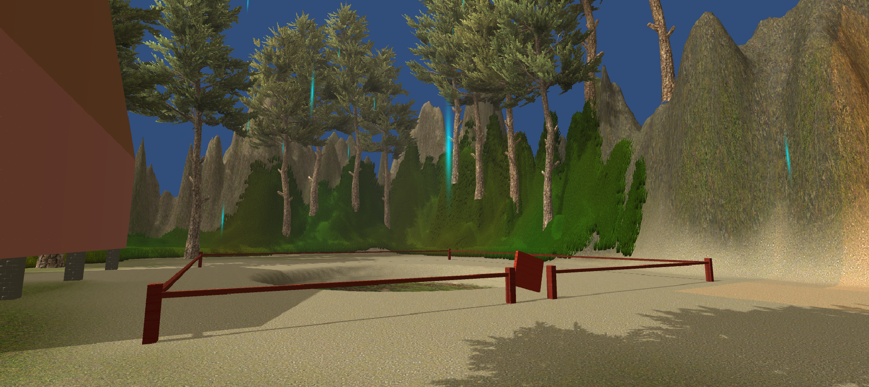

Figure 15: Raining Particle System

## 7. Physics

**Features used**:

* A **rotate physics** was made and using joints

**Where in Hierarchy**

* /Fence/BrokenDoor

**Description**:

BrokenDoor use hinge joint to joint the fence near it. It has physic such that when player want push it, it will open. This is set to loosen strength because it has been broken.

**Screenshot**:

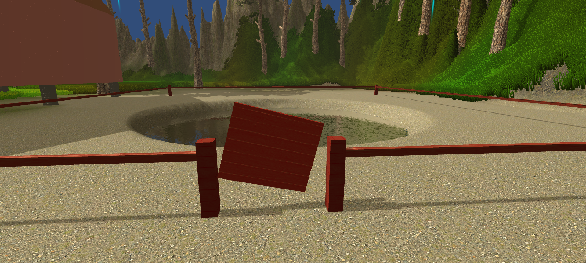

Figure 16: Broken door with joint

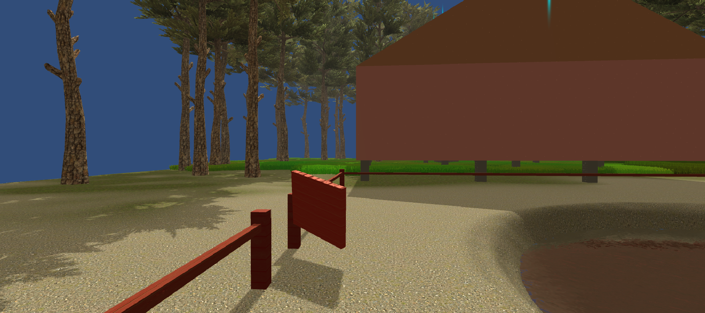

Figure 17: Broken door with joint and physic

# Assets Used

You are allowed to use any 3rd party assets (models, textures, scripts, music, sfx, etc) in creating your game, so long as you have license to use them. Copyright violation is a breach of academic integrity and will be treated appropriately. Your report **must** include a list of all such assets that you use in your game.

## Textures

* **Grass** – Terrain Tools Sample Asset Pack, by Unity Technologies
* **Wood** - DryTree, by Andrey Graphics (From Asset Store)
* **Bricks** – StoneWalls, by Bigminigeek (From Asset Store)
* **FireParticle** – Standard Assets (ParticleSystems), by Unity Technologies
* **RainingParticle** – Standard Assets (ParticleSystems), by Unity Technologies

## Details

* Grass Billboard, Standard Assets (Environment), by Unity Technologies
* Grass Frond 02 Billboard, Standard Assets (Environment), by Unity Technologies

## Models

* AddOns, by Unity Technologies (From Asset Store)
* Low Poly Bed Room Furniture, by Dreamerz Lab LTD. (From Asset Store)
* Pottery, by 3D.Rina (From Asset Store)
* RawWoodenFurnitureFree, by Ambimesh (From Asset Store)
* Rocks and Boulders 2, by Mnufactura K4 (From Asset Store)

## Scripts

* ClickToAnim
* TriggerToAnim

## Audio

* Rain- And- Wind- A, by Fesliyan Studios, (<https://www.fesliyanstudios.com/royalty-free-sound-effects-download/rain-21>)

## Tools

* Terrain Tools, by Unity Technologies (from Package Manager)
* ProBuilder, by Unity Technologies (from Package Manager)
* Post Processing, by Unity Technologies (from Package Manager)